**DRIVER CLASS:**

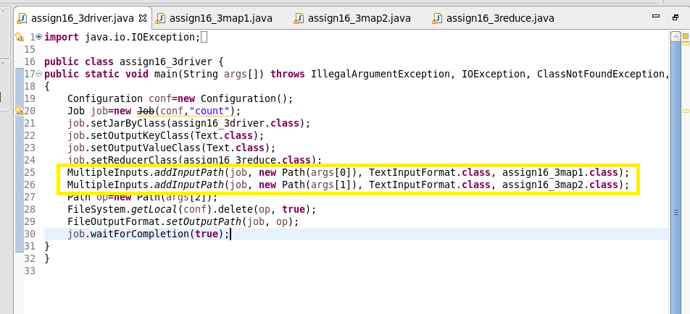

**MAPPER CLASS:**

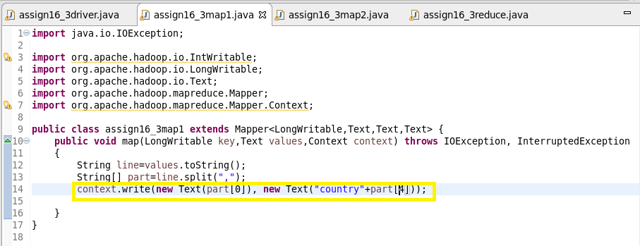

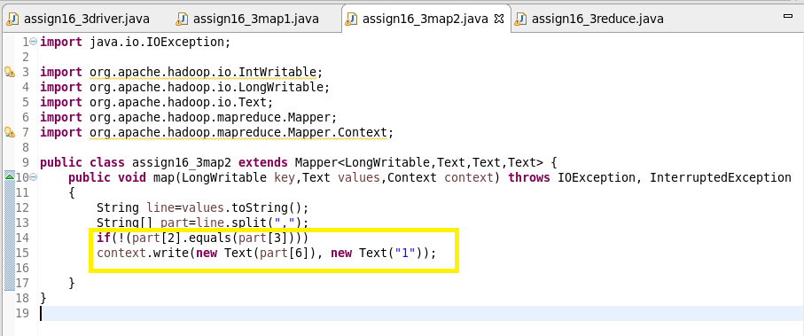

**REDUCER CLASS:**

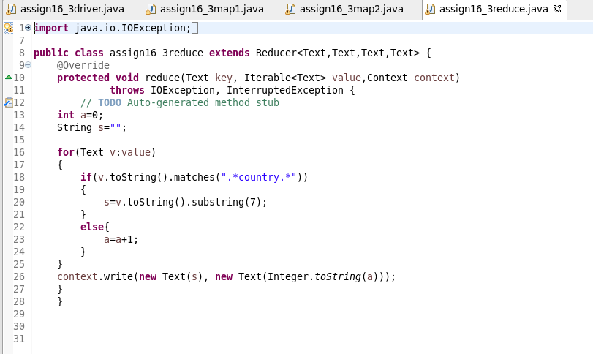

**RUNNING JAR:**

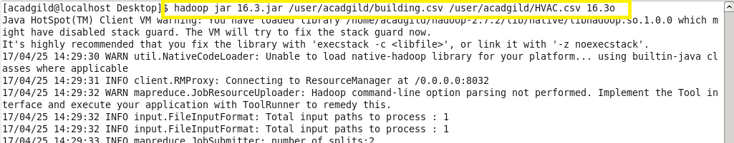

**OUTPUT:**

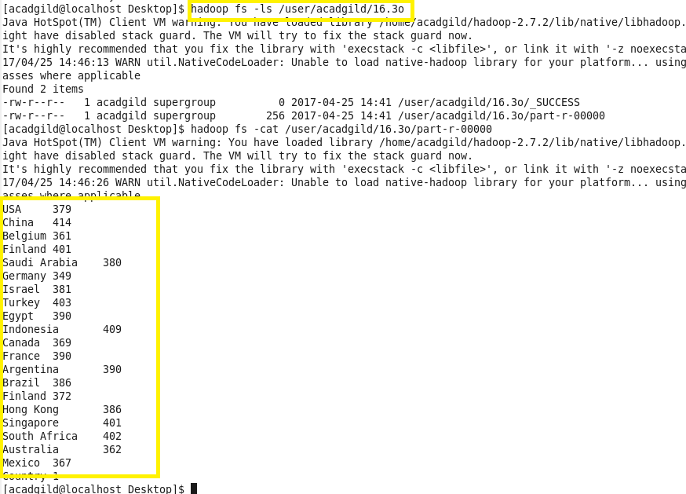

*It is slower and less efficient than the Map Side join.